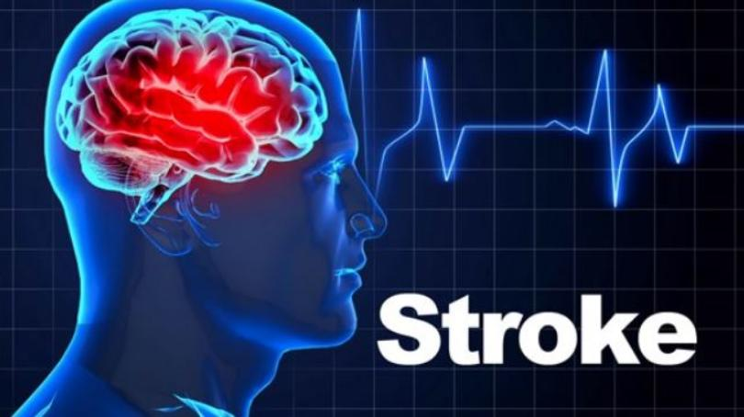
Seminar on Stroke
Sonny Yamasaki, Ph.D.
Free & Open to the Public
Where: Seabrook Buddhist Temple Social Hall, 9 Northville Road, Bridgeton, NJ 08302
Date: Saturday, October 20, 2018
Time: 2:00 pm
Sponsors: Seabrook Buddhist Temple, Japanese American Citizens League, and Seabrook Educational and Cultural Center
Topics covered:
- What is stroke?
- Warning signs
- Risk factors
- Latest devices, treatments, & clinical trials that are revolutionizing the field
- What to do if you or a loved one is experiencing a stroke
- What to expect at the hospital and what to ask for
- Brochures, handouts with Stroke Centers near you and stroke websites
Refreshments will be served. Please contact the Temple at 856-451-3422 if you are planning to attend to allow for proper planning for refreshments.
The speaker: Sonny Yamasaki was born and raised in Seabrook, and attended the Buddhist Temple. He is Founder and President of Enso Medical Technologies, Inc (a startup medical device company). Prior to Enso, he was a scientist at Medtronic (the world’s first and largest medical device company). While there, he was Director of New Therapy Development responsible for identifying as well as inventing/developing new medical technologies and therapies for the company. He was Medtronic’s lead stroke expert for 15 years and worked with many of the pioneering stroke neurointerventional surgeons in the US and EU.

